**PROGRAMMING & PROBLEM SOLVING**

**PROJECT REPORT**

**C1 Bank & Management System**

Anvit Pawar Anya Gupta

RA2111003010182 RA2111003010152

CSE CORE CSE CORE

C1 Section C1 Section

**Objective :**

The C1 Bank & Management System is an application for keeping a singulars’ record in a bank. In this venture, we have shown the working of a Bank's administration framework by covering the fundamental usefulness which:

1. Withdraws money
2. Deposits money
3. Views Account Details

The project uses the C language for complete functionality.

**Problem Definition :**

The given program helps the user with their day-to-day basic banking needs and manages their bank account to withdraw, deposit, and check cash in the account. Basic banking can be performed with ease when username, password, and debit card pin is entered and the user passes the security check.

First a user is asked to enter credentials, then they login to a menu to perform desired transaction out of the given options and to exit when done. Security features are also added to the program for safe and trustworthy experience.

**Flowchart**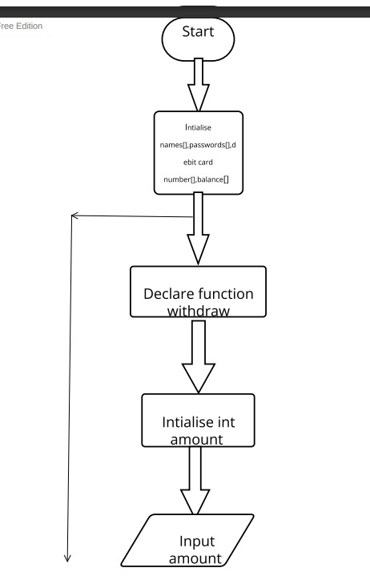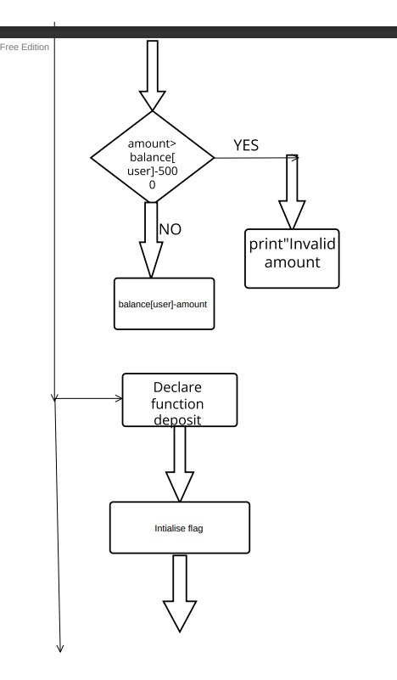

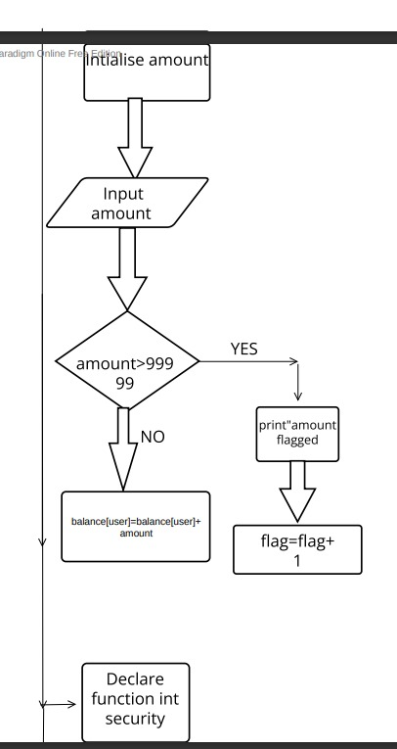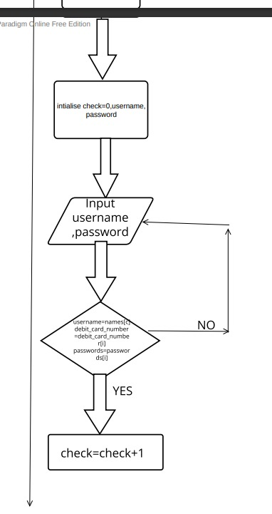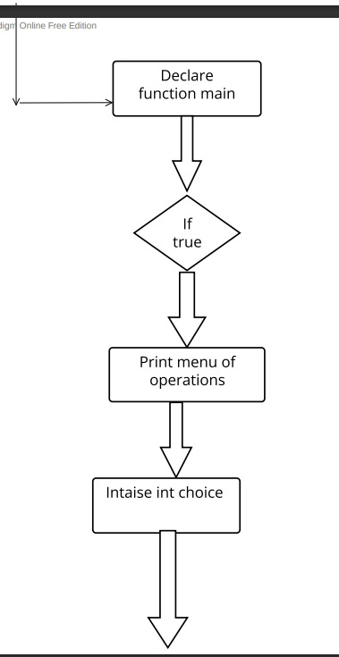

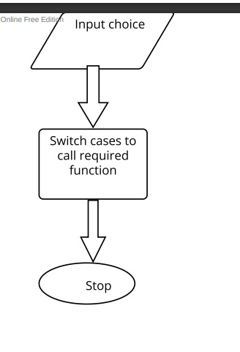

**ALGORITHM**

**Step 1** - Start

**Step 2** - Initialize names[ ], passwords[ ], debit_card_numbers[ ], and balance[ ]

**Step 3** - Declare a function void withdraw

Step 3.1 - If flag of User is greater than 3, print Credit transactions unavailable

Step 3.2 - Else i) Initialize and input amount

ii) If amount is greater than balance[user]-5000, then print “invalid amount”

iii) Else decrement balance[user] by amount

**Step 4** - Declare a function void deposit

Step 4.1 - If flag of User is greater than 3, print Debit transactions unavailable

Step 4.2 - Else i) Initialize and input amount

ii) If amount is greater than 99999, then print “The amount you are trying to deposit is higher than the usual amount.” and “The debit transaction has been flagged.", then increment flag by 1

iii) If flag of User is greater than 3, print “The Debit transaction was unsuccessful”

iv) Else Increment balance[user] by amount

**Step 5** - Declare a function void view_details

Step 5.1 - Print name[user], debit_card_numbers[user], and balance[user]

**Step 6** - Declare a function int security

Step 6.1 - Declare check = 0, username, debit_card_number and password

Step 6.2 - Input username, debit_card_number and password

Step 6.3 - Use For Loop

1. If username = names[i], debit_card_number = debit_card_numbers[i] and password = passwords[i], increment check by 1
2. If check is equal to 3, break the loop

Step 6.4 - If Check is less than 3, print “Invalid Username/Password/Debit Card Number"

Step 6.5 - Return -1

Step 6.6 - Else print “Successfully logged in” and Return i

**Step 7** - Declare a function void main

Step 7.1 - Initialize cont

Step 7.2 - Call the function Security and assign the returned value to cont

Step 7.3 - If cont equals -1, exit(0)

Step 7.4 - Else run an infinite while loop

1. Print a menu for operations using print statements, with one value for ending the program
2. Initialize and input int choice from the user
3. Use switch case to call required function depending upon the value of choice iv) If the default value is called, then print “invalid choice!”

**Step 8** – Stop

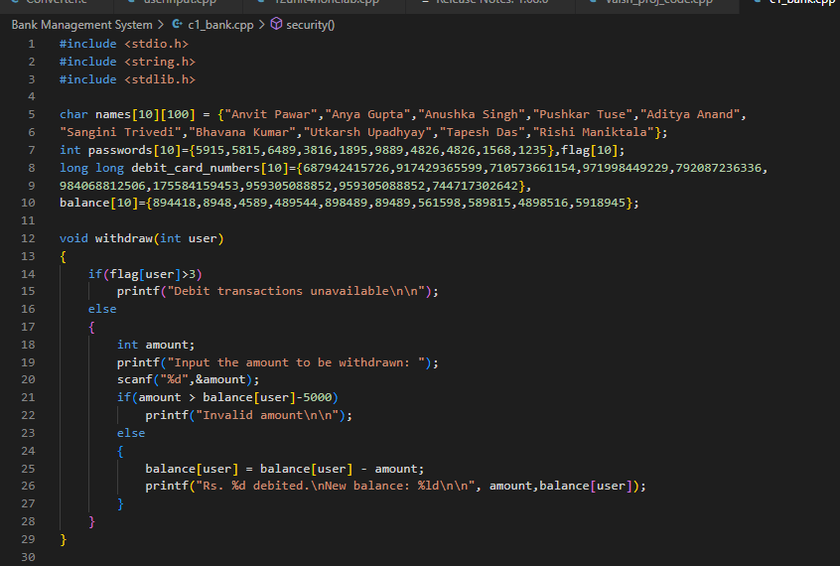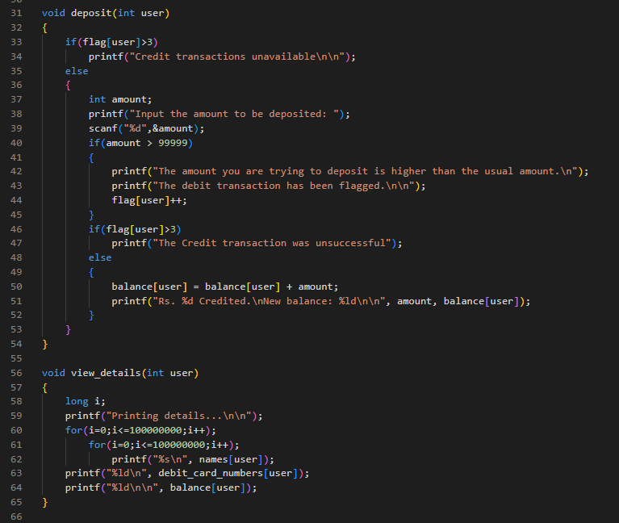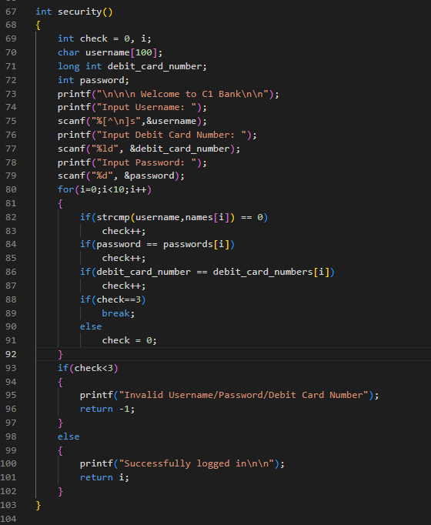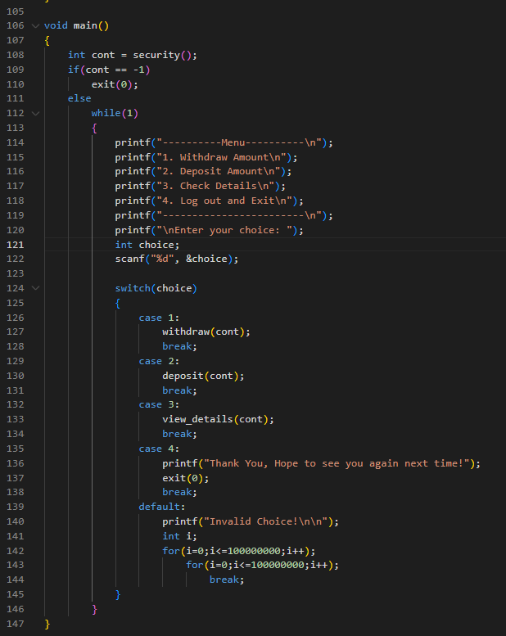

Program in VS Code

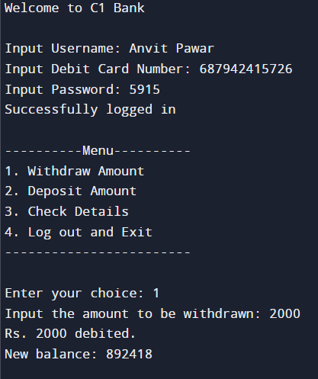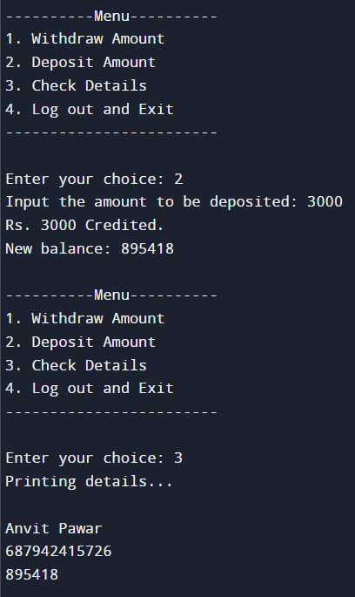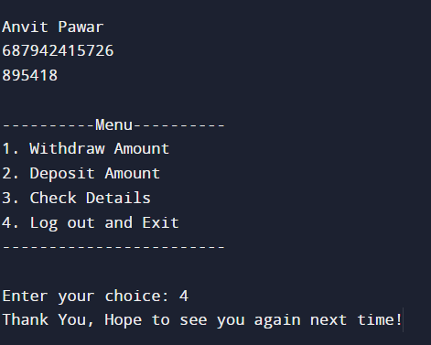

**Output :**